**B”H**

**Chapter 1**

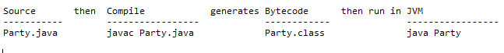

* A source code file (.java) can contain multiple classes - when compiled it results in one “.class” file per class
* Inside classes you put methods
* Inside methods you put statements
* Every Java app must have at least one class and at least one main method.
* Java is OO so everything has to be in a class.
* Not every class requires a main method; only the one that starts the program running.
* Additionally, you might write test classes that have a main method - with these classes you can test other classes.
* Code blocks are defined by curly braces.
* **System.out.println** prints to a new line whereas **System.out.print** does to same line.
* <http://examples.oreilly.com/9780596009205/> has the code for the book
* Java has three standard looping constructs: while, do-while, and for.
* You can do a simple boolean test by checking the value of a variable, using a comparison operator including:
  + < (less than)
  + > (greater than)
  + == (equality) (two equals signs)
* Notice the difference between the assignment operator (a single equals sign) and the equals operator (two equals signs).
* Use good commenting such as saying what the end curly brace belongs to, like:

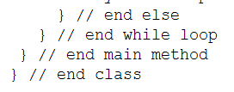

* Use [] to create an array; such as: **String[] pets = {" Fido", "Zeus", "Bin"};**
* random() method returns a random number between 0 and not-quite-1,
* Java is a strongly-typed language, which means the compiler can’t allow variables to hold data of the wrong type.